**Database**

The book database contains four tables:

1. Users table - to hold user registration and password details. Each user is uniquely identified by a user name.

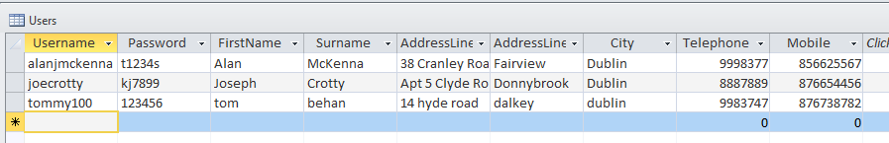

1. Books table - holding all book details, indexed by ISBN number

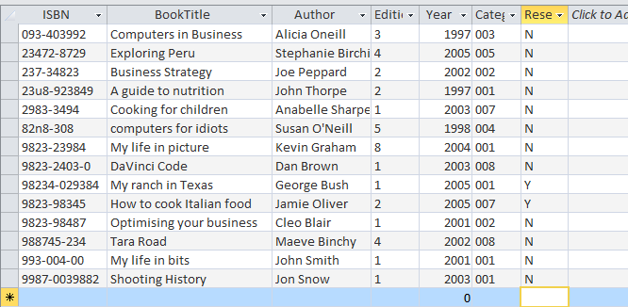

1. Category table – indicating the list of book categories (fiction, business etc). It is linked to the Books table by category code

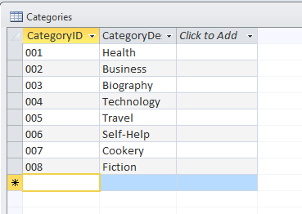

1. Reserved Books table - holding a list of books reserved by the user   
   (identified by username). It is linked to the books table by ISBN number   
   and the Users table by username.

